
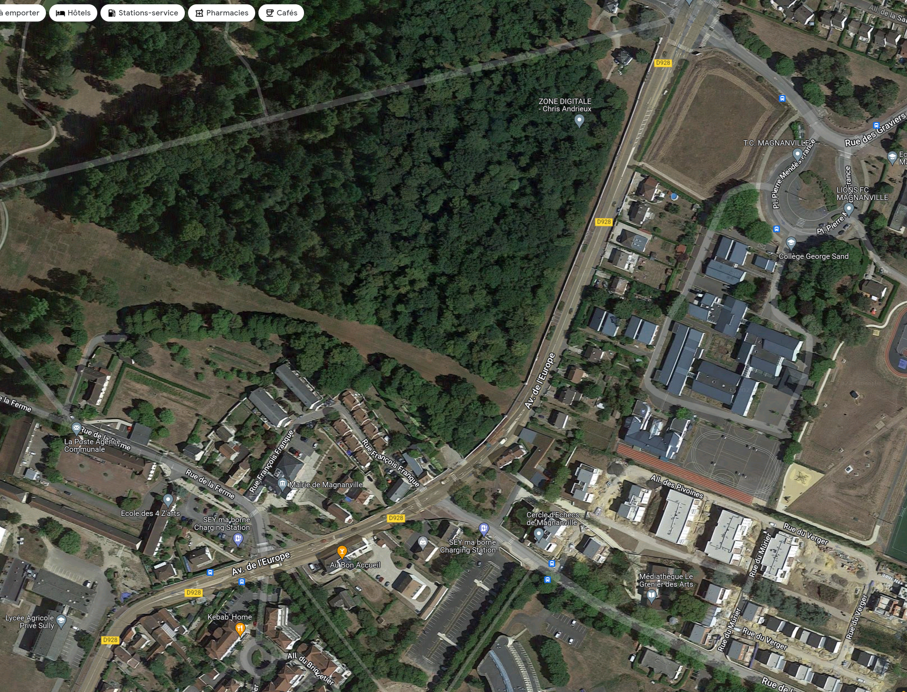
Traces GPX
- 40 km : https://www.openrunner.com/r/7070485
- 76 km : https://www.openrunner.com/r/7070520
- 101 km : https://www.openrunner.com/r/7070548
- 47 Km Gravel/VTT : https://www.openrunner.com/route-details/20246717
Traces FIT (Garmin)
- 40 km : https://connect.garmin.com/modern/course/97505180
- 76 km : https://connect.garmin.com/modern/course/97505465
- 101km : https://connect.garmin.com/modern/course/97505697
- 47 Km Gravel/VTT : https://connect.garmin.com/modern/course/319269893

INSCRIPTIONS

